**REACT (WEEK-7)**

**9.REACTJS-HOL**

**App.js**

import React, { useState } from 'react';

import ListofPlayers from './components/ListofPlayers';

import IndianPlayers from './components/IndianPlayers';

function App() {

const [flag, setFlag] = useState(true);

return (

<div className="App">

<h1>Cricket App</h1>

<button onClick={() => setFlag(!flag)}>Toggle Flag</button>

{flag ? <ListofPlayers /> : <IndianPlayers />}

</div>

);

}

export default App;

**components/ListofPlayers.js**

import React from 'react';

const ListofPlayers = () => {

const players = [

{ name: 'Virat Kohli', score: 90 },

{ name: 'Rohit Sharma', score: 85 },

{ name: 'KL Rahul', score: 60 },

{ name: 'Hardik Pandya', score: 45 },

{ name: 'Ravindra Jadeja', score: 55 },

{ name: 'Shubman Gill', score: 92 },

{ name: 'Jasprit Bumrah', score: 70 },

{ name: 'R Ashwin', score: 30 },

{ name: 'Suryakumar Yadav', score: 65 },

{ name: 'Ishan Kishan', score: 75 },

{ name: 'Mohammed Siraj', score: 50 },

];

const filteredPlayers = players.filter(player => player.score < 70);

return (

<div>

<h2>All Players with their Scores</h2>

<ul>

{players.map((player, index) => (

<li key={index}>{player.name} - {player.score}</li>

))}

</ul>

<h2>Players with Score Below 70</h2>

<ul>

{filteredPlayers.map((player, index) => (

<li key={index}>{player.name} - {player.score}</li>

))}

</ul>

</div>

);

};

export default ListofPlayers;

**components/IndianPlayers.js**

import React from 'react';

const IndianPlayers = () => {

const allPlayers = ['Player1', 'Player2', 'Player3', 'Player4', 'Player5', 'Player6'];

// Destructuring

const [p1, p2, p3, p4, p5, p6] = allPlayers;

const oddTeam = [p1, p3, p5];

const evenTeam = [p2, p4, p6];

// Merge arrays using ES6 spread operator

const T20players = ['Virat', 'Rohit', 'Bumrah'];

const RanjiTrophyPlayers = ['Shreyas', 'Rahane'];

const mergedPlayers = [...T20players, ...RanjiTrophyPlayers];

return (

<div>

<h2>Odd Team Players</h2>

<ul>

{oddTeam.map((player, index) => (

<li key={index}>{player}</li>

))}

</ul>

<h2>Even Team Players</h2>

<ul>

{evenTeam.map((player, index) => (

<li key={index}>{player}</li>

))}

</ul>

<h2>Merged T20 and Ranji Trophy Players</h2>

<ul>

{mergedPlayers.map((player, index) => (

<li key={index}>{player}</li>

))}

</ul>

</div>

);

};

export default IndianPlayers;

**index.js**

import React from 'react';

import ReactDOM from 'react-dom/client';

import App from './App';

const root = ReactDOM.createRoot(document.getElementById('root'));

root.render(<App />);

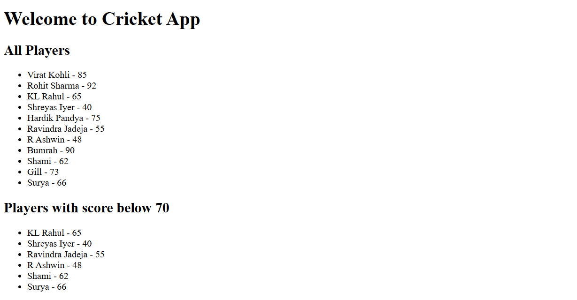

**10.REACTJS –HOL**

**App.js**

import React from 'react';

function App() {

// Object to store a single office detail

const singleOffice = {

name: "Elite Business Suites",

rent: 55000,

address: "MG Road, Bengaluru",

image: "https://via.placeholder.com/300x200?text=Office+Image"

};

// List of office space objects

const officeList = [

{

name: "Prestige Tech Park",

rent: 45000,

address: "Outer Ring Road, Bengaluru"

},

{

name: "WeWork Residency",

rent: 65000,

address: "Church Street, Bengaluru"

},

{

name: "Innov8 Coworking",

rent: 70000,

address: "Koramangala, Bengaluru"

}

];

// Style function for rent

const getRentStyle = (rent) => {

return {

color: rent < 60000 ? "red" : "green",

fontWeight: "bold"

};

};

return (

<div style={{ padding: '20px', fontFamily: 'Arial' }}>

{/* Heading */}

<h1>Office Space Rental App</h1>

{/* Image of the office */}

<img src={singleOffice.image} alt="Office" style={{ width: '300px', height: '200px' }} />

{/* Single Office Details */}

<h2>{singleOffice.name}</h2>

<p><strong>Address:</strong> {singleOffice.address}</p>

<p>

<strong>Rent:</strong>

<span style={getRentStyle(singleOffice.rent)}> ₹{singleOffice.rent}</span>

</p>

{/* Office List */}

<h2>Available Office Spaces</h2>

{officeList.map((office, index) => (

<div key={index} style={{ marginBottom: '15px' }}>

<p><strong>Name:</strong> {office.name}</p>

<p><strong>Address:</strong> {office.address}</p>

<p>

<strong>Rent:</strong>

<span style={getRentStyle(office.rent)}> ₹{office.rent}</span>

</p>

<hr />

</div>

))}

</div>

);

}

export default App;

**index.js**

import React from 'react';

import ReactDOM from 'react-dom/client';

import App from './App';

const root = ReactDOM.createRoot(document.getElementById('root'));

root.render(<App />);

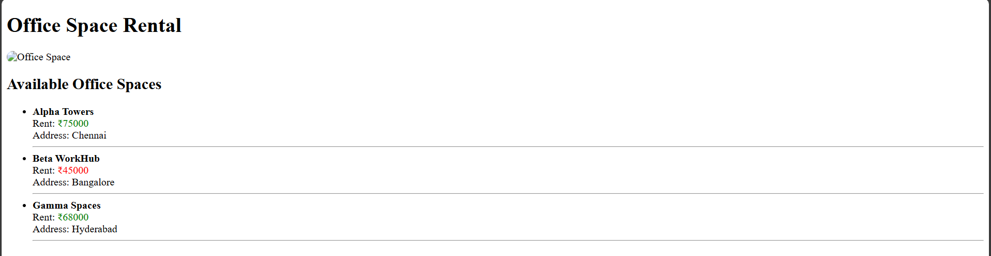

**11.REACTJS-HOL**

**App.js**

import React from 'react';

import './App.css';

import Counter from './Counter';

import WelcomeButton from './WelcomeButton';

import ClickMeButton from './ClickMeButton';

import CurrencyConverter from './CurrencyConverter';

function App() {

return (

<div className="main-container">

<Counter />

<WelcomeButton />

<ClickMeButton />

<CurrencyConverter />

</div>

);

}

export default App;

**App.css**

body {

font-family: Arial, sans-serif;

padding: 20px;

background-color: #fff;

}

.main-container {

margin-left: 30px;

}

button {

display: block;

margin: 10px 0;

padding: 8px 16px;

border: 1px solid #ccc;

background-color: #f0f0f0;

cursor: pointer;

}

h2 {

color: green;

}

**Counter.js**

import React, { useState } from 'react';

function Counter() {

const [count, setCount] = useState(1);

const increment = () => setCount(count + 1);

const decrement = () => setCount(count - 1);

return (

<div>

<p>{count}</p>

<button onClick={increment}>Increment</button>

<button onClick={decrement}>Decrement</button>

</div>

);

}

export default Counter;

**WelcomeButton.js**

import React from 'react';

function WelcomeButton() {

const sayWelcome = () => {

alert("Welcome!");

};

return (

<button onClick={sayWelcome}>Say welcome</button>

);

}

export default WelcomeButton;

**ClickMeButton.js**

import React from 'react';

function ClickMeButton() {

const handleClick = () => {

alert("Click on me");

};

return (

<button onClick={handleClick}>Click on me</button>

);

}

export default ClickMeButton;

**CurrencyConverter.js**

import React from 'react';

function ClickMeButton() {

const handleClick = () => {

alert("Click on me");

};

return (

<button onClick={handleClick}>Click on me</button>

);

}

export default ClickMeButton;

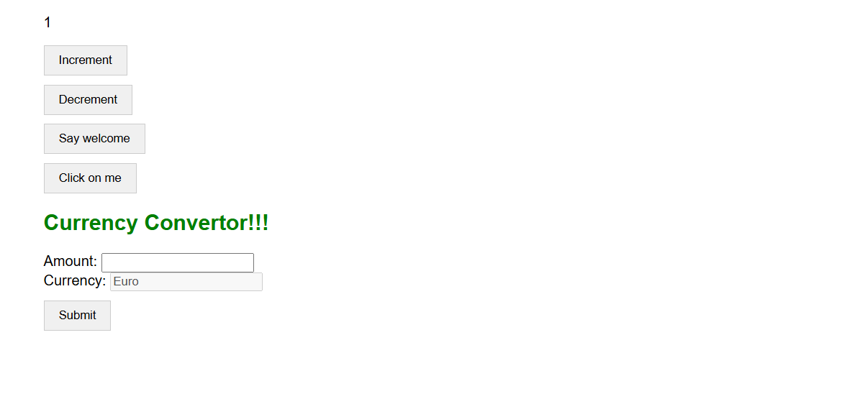

**12.REACTJS-HOL**

**App.js**

import React, { useState } from 'react';

function App() {

const [isLoggedIn, setIsLoggedIn] = useState(false);

const handleLogin = () => setIsLoggedIn(true);

const handleLogout = () => setIsLoggedIn(false);

const GuestPage = () => (

<div>

<h2>Welcome, Guest!</h2>

<p>You can view flights, but please log in to book tickets.</p>

<button onClick={handleLogin}>Login</button>

</div>

);

const UserPage = () => (

<div>

<h2>Welcome, User!</h2>

<p>You are logged in. You can book your flight tickets now.</p>

<button onClick={handleLogout}>Logout</button>

</div>

);

return (

<div className="App">

<h1>✈️ Ticket Booking App</h1>

{isLoggedIn ? <UserPage /> : <GuestPage />}

</div>

);

}

export default App;

**App.css:**

body {

font-family: Arial, sans-serif;

background-color: #f2f2f2;

padding: 20px;

text-align: center;

}

button {

padding: 10px 20px;

margin-top: 10px;

}

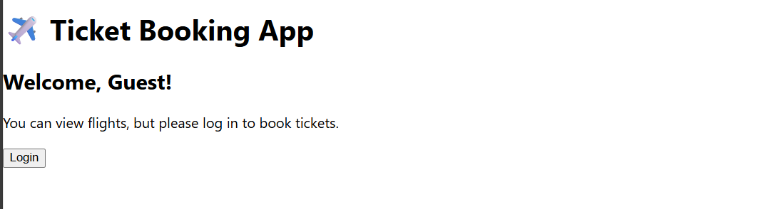

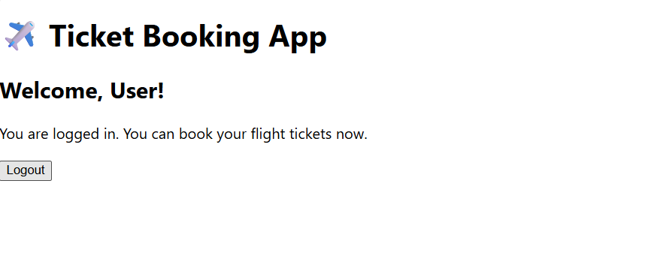

**13.REACTJS-HOL**

**App.js**

import React from 'react';

import './App.css';

import CourseDetails from './CourseDetails';

import BookDetails from './BookDetails';

import BlogDetails from './BlogDetails';

function App() {

return (

<div className="App">

<h1>Blogger App</h1>

<div className="container">

<CourseDetails />

<BookDetails />

<BlogDetails />

</div>

</div>

);

}

export default App;

**Coursedetails.js**

import React from 'react';

function CourseDetails() {

const courses = [

{ name: 'Angular', date: '4/5/2021' },

{ name: 'React', date: '6/3/20201' }

];

return (

<div className="column">

<h2>Course Details</h2>

{courses.map((course, index) => (

<div key={index}>

<h3>{course.name}</h3>

<p>{course.date}</p>

</div>

))}

</div>

);

}

export default CourseDetails;

**BookDeatils.js**

import React from 'react';

function BookDetails() {

const books = [

{ title: 'Master React', price: 670 },

{ title: 'Deep Dive into Angular 11', price: 800 },

{ title: 'Mongo Essentials', price: 450 }

];

return (

<div className="column">

<h2>Book Details</h2>

{books.map((book, index) => (

<div key={index}>

<h3>{book.title}</h3>

<p>{book.price}</p>

</div>

))}

</div>

);

}

export default BookDetails;

**BlogDetails.js**

import React from 'react';

function BlogDetails() {

const blogs = [

{

title: 'React Learning',

author: 'Stephen Biz',

content: 'Welcome to learning React!'

},

{

title: 'Installation',

author: 'Schwezdenier',

content: 'You can install React from npm.'

}

];

return (

<div className="column">

<h2>Blog Details</h2>

{blogs.map((blog, index) => (

<div key={index}>

<h3>{blog.title}</h3>

<strong>{blog.author}</strong>

<p>{blog.content}</p>

</div>

))}

</div>

);

}

export default BlogDetails;

**App.css**

body {

font-family: Arial, sans-serif;

padding: 20px;

background-color: #fff;

}

h1 {

text-align: center;

margin-bottom: 40px;

}

.container {

display: flex;

justify-content: space-around;

gap: 20px;

}

.column {

flex: 1;

border-left: 4px solid green;

padding: 0 20px;

}

.column:first-child {

border-left: none;

}

h2 {

font-size: 22px;

margin-bottom: 20px;

}

h3 {

font-size: 18px;

margin: 10px 0 5px;

}

p {

font-size: 14px;

margin: 0 0 15px;

}

strong {

display: block;

margin-bottom: 5px;

}